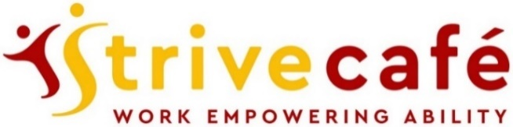

**Home-made Cakes & Scones**

Cup Cakes: Chocolate Malteser, Lemon Drizzle, Victoria Sponge, Coffee & Walnut, Carrot cup-cake £2.50 each Cup Cake with an ice cream (see below) £4.50

Nat’s shortbread, Luxury Flapjack £2.00

Cheese scone with butter £2.50 Plain scone or fruit scone with butter £2.00 Jam 50p, Clotted cream £1

**Snacks, Crisps and Ice Cream**

Wicked Rocky Road £2.00 Millionaire’s Shortbread, Butter Flapjack £1.50 Toasted tea cake with butter £2.00

Crisps: sea salt and cider vinegar, cheese and onion, sea salt, chorizo £1.00

Ice cream: chunky chocolate, clotted cream vanilla, strawberry and clotted cream, salted caramel £2.00

**Gluten-free and Vegan snacks**

Gluten free home-made chocolate brownie £2.50 G-f Salted caramel brownie, G-f Blueberry muffin £2.50 G-f scone & butter £2.00, G-f spiced granola bar £1.50 G-f and vegan crisps: Hummus salted, Lentil tomato & basil, £1.00

Vegan & gluten-free spiced granola bar £1.50 Vegan flapjack £1.50, Vegan crisps see above £1.00 Vegan ice cream: chocolate £2.00

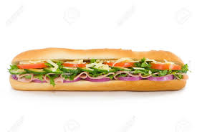

**Hot drinks**

Mug of Tea any flavour £1.50

Small Teapot £2.00, Large Teapot £3.00

Americano, Flat White, Cappuccino £2.00

Espresso £1.50, Double Espresso £2.00

Latte, Mocha, Macchiato £2.50

Hot Chocolate £2.50, Ultimate +50p

Flavours: Caramel, Gingerbread

Vanilla, Hazelnut, Salted Caramel +50p

Milks: Soya, Almond, Coconut +50p

Welcome! We are following government guidelines to assist with safe operations. Social distancing should be adhered to at all times. We have additional cleaning and systems to support a healthy environment.

* **Only one person at a time from your table** should go to the counter to order food and pay
* Please use the hand sanitisers positioned throughout the café
* Particularly when the café is busy, please remain in your seat where possible
* Cutlery and condiments will be brought to your table with your food
* **We will clear your table after you have left**
* Side tables are provided to maintain distance between you and staff



**Cold Drinks**

Coke, Diet Coke, Sprite, Fanta, Still & Sparkling Water £1.50

Oasis: Blackcurrant & Apple, Summer Fruit, Citrus £1.50

Iced Tea: Peach, Raspberry, Lemon, Mango £1.50

Juice Burst: Orange, Tropical, Apple £1.50

Elderflower Cordial, Ginger Beer £2.00



**\*Strive fillings:** Cheese, Ham, Cheese and Ham, Tuna Mayo or Baked Beans - with tomato or lettuce.

**\*Superstrive fillings** +£1: BLT, Coronation Chicken, Sausage, Bacon & Avocado

Extras +£1 Avocado, Coleslaw, Bacon, Sausage

Gluten-free breads available Flora, Mayo or plain on request

**See our Daily Specials Board**

**Strive Meal Deal**

Strive filled* baguette, sandwich or roll with cold drink and packet of crisps £4.50

Superstrive meal deal with superior filling £5.50

**Baguettes, Sandwiches, Rolls with a choice of fillings**

Brown or white Sandwiches or Roll, white Baguette, or gluten free bread with various fillings* with salad garnish £3.50 

**Hot Food**

Toasties: any combo of cheese, ham, tomato, white or brown bread with salad garnish £4.50

Baked potato with choice of fillings* and salad garnish £4.50

Home-made Sausage Roll or Scotch Egg £3.50

Lasagne with chips or salad £6.50

Luxury hot-dog & onions with chips or salad £8.00

Burger& onion rings with chips or salad £9.50

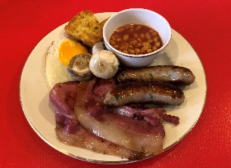

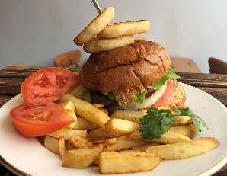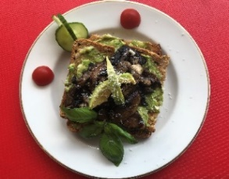

**All-day breakfast options**

Full Cooked Breakfast: 2 slices of Bacon, Jamie’s prize-winning Sausage or Vegan Sausage, Fried Egg, Mushroom, Tomato, Beans, Hash brown £5.50

Mix & match breakfast available: add Black Pudding, extra Egg, Tomato, Mushrooms, Hash Brown for 50p each or extra Sausage or Bacon £1.00 each, or Toast with butter £1.00

Jamie’s prize-winning sausage in a roll £4.00

Bacon in a roll £3.50

Poached eggs on toast £3.50

Poached eggs on toast with avocado £4.50

Cheese on toast brown or white 2 slices £4.50

Beans on toast brown or white 2 slices £4.00

2 toast with butter £1.50 Toasted teacake with butter £2.00 Jam, marmalade, honey or Marmite 50p

Vegetarian quiche with salad garnish £5.50

Vegan sausage in a roll £4.00

Side Salad £2.50

Garlic Bread £2.00

Avocado on toast 2 slices, with tomato or mushrooms topped with basil and parmesan cheese £5.50

*Food is freshly prepared, so requests welcome*

*100% of tips shared equally between staff on shift*

***We are******NOT an allergen-free environment.*** *Please speak with the Manager before ordering*